Bellabeat Case Study Report

1. Business Task (ASK)
Bellabeat, a smart wellness product company, wants to understand how users engage with fitness trackers. Using Fitbit consumer data, the goal is to discover user behavior patterns and create actionable insights to improve Bellabeat’s marketing strategy.

2. About the Dataset (PREPARE)
Source: Fitbit Fitness Tracker Data (Kaggle - uploaded by Mobius)
License: CC0 Public Domain
Date Range: April 12 – May 12, 2016
Participants: 30
Files used: Daily activity, sleep, steps, calories, intensities.

3. Data Cleaning & Preparation (PROCESS)
• Cleaned and standardized column names
• Converted date columns to proper DATE format
• Removed duplicates from sleep dataset
• Joined daily activity with sleep data using Id + Date
• Checked for NA values and inconsistencies
• Created additional fields such as weekday and hours asleep

4. Analysis & Findings (ANALYZE)
Key insights:
• Average daily steps: 7,638
• Median daily steps: 7,406
• Average calories burned: 2,304 kcal
• Average sleep duration: 419 minutes (~7 hours)
• Only 32.2% of days reached 10,000+ steps
• Weekend (Saturday) has highest activity
• Steps and calories have moderate correlation (0.59)

5. Visualizations (Created in Tableau Public)

Steps vs Calories (Tableau Visualization)
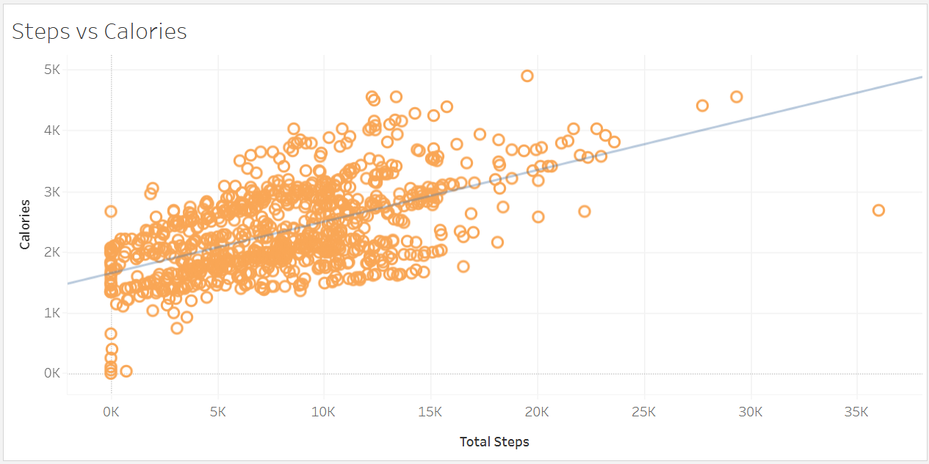

Daily Steps Over Time (Tableau Visualization)
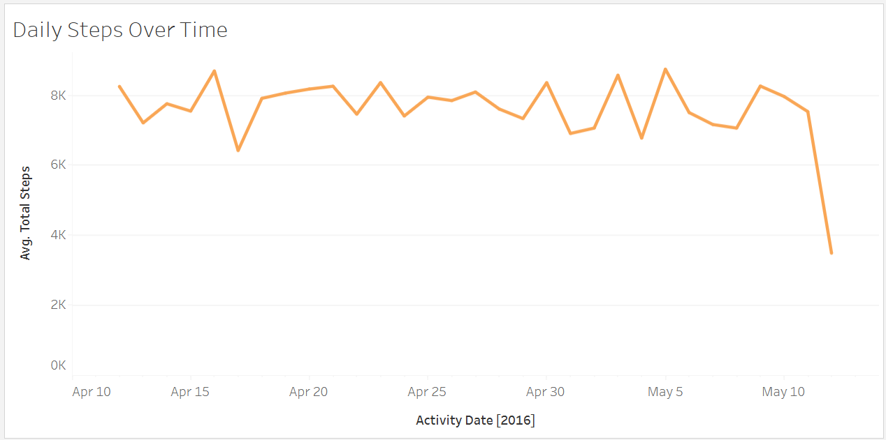

Sleep vs Steps (Tableau Visualization)
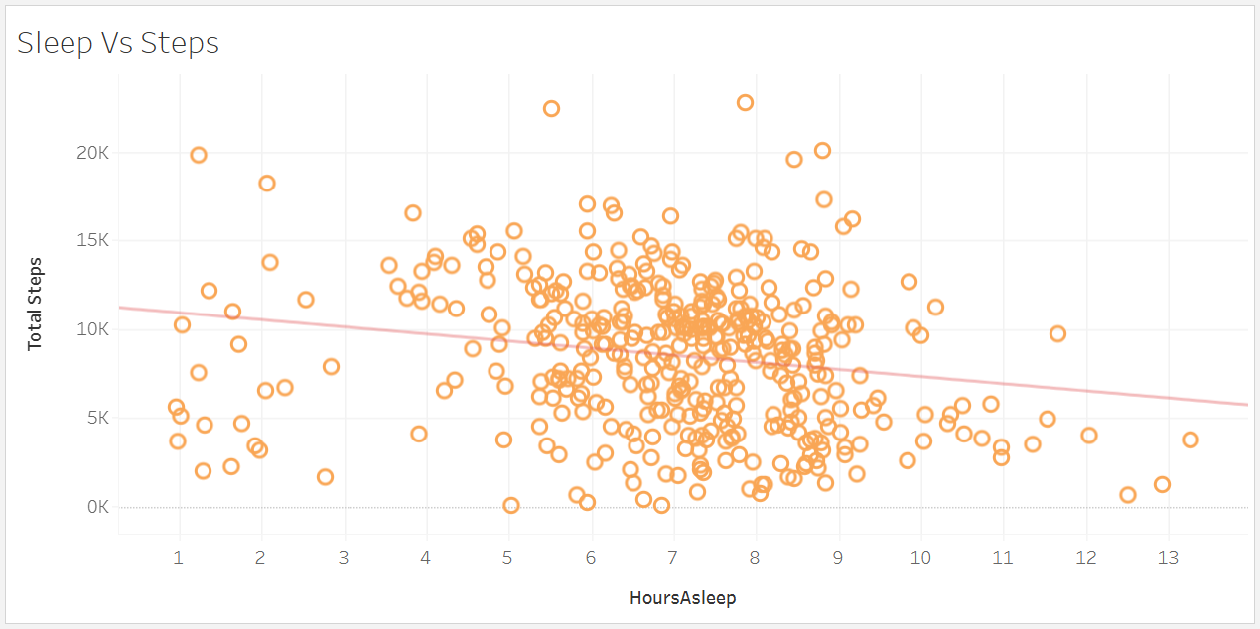

6. Recommendations (ACT)
Based on the analysis, the following recommendations were developed:
1. Introduce weekend step challenges to boost engagement.
2. Add smart reminders on low-activity days (Sun, Thu, Fri).
3. Provide personalized sleep insights and bedtime reminders.
4. Use progressive step goals (8k → 9k → 10k) to encourage improvement.
5. Promote calorie burn achievements using real-time feedback.

7. Conclusion
Fitbit user data reveals patterns in daily steps, calories, and sleep. Bellabeat can use these insights to improve user engagement, encourage healthier habits, and promote the value of their smart devices.

8. Data Source & Credits
Dataset: Fitbit Fitness Tracker Dataset
Source: Kaggle (uploaded by user “Mobius”)
License: CC0: Public Domain License
This analysis, visualizations, and report are entirely my own work, created for the Google Data Analytics Capstone Case Study. I do not claim ownership of the dataset.

